
Year 12 Physics - Motion and Forces in a
Gravitational Field

Test 1 – Motion Review and Projectile Motion
Name: | Teacher: | Score / 45
Comment: |  |  | Time allowed:  50 minutes

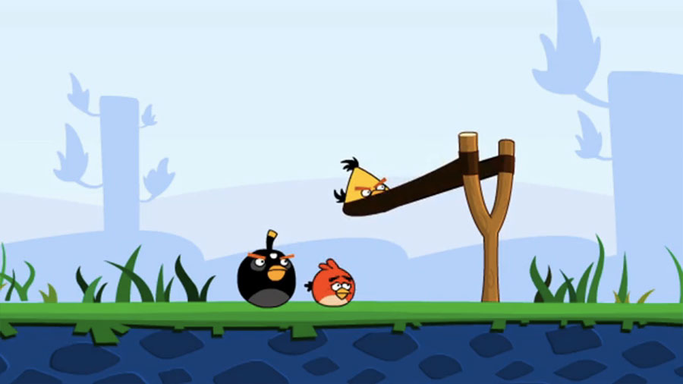

Answer all questions on the paper provided
To achieve full marks, clear, logical working and diagrams MUST be shown.
Answers should be evaluated with an appropriate number of significant figures.
Section A: Short Answer: 28 marks

- A Battleship simultaneously fires two shells at enemy ships located at different distances as shown below.
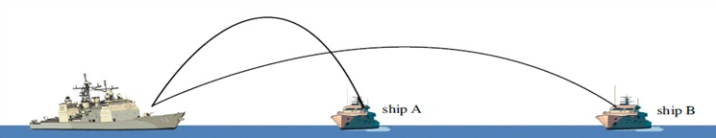

- Which enemy ship gets hit FIRST? (Circle Answer)

Ship A Ship B Both Ships at the same time
(2 Marks)
- Briefly explain your answer to part a

(2 marks)

- You throw a 0.100 kg ball up into the air and it reaches a height of 3.25 m above its release point. It then returns to the ground, which is 0.750 m below where it was released. Explaining your logic, calculate the energy lost as it hits the ground.

(3 marks)

- You are doing a movie stunt. You have to leap from one roof to another, 2.50 m away. There is a drop of 50.0 m if you fail (splat!!). You take a long run up and upon a signal from the director you leap over the gap. Draw a free body diagram showing all the forces acting on you at the moment you reach the half-way point. (Stick figure is fine)

(2 marks)
- Mark Weber slows his formula one racing car down from 50.0 ms⁻¹ to a stop in 12.5s as he crosses the line to win the Australian Grand Prix.

- Determine the cars acceleration.

(2 marks)

- Calculate how far from the finish line Webber is when his car comes to a stop

(3 marks)

- Simon was driving home one day when his car broke down... The tow truck had a flat tray which travelled out backwards from the frame of the tow truck and tilted until it was under the front wheels of the car at an angle of 30.0˚ to the horizontal. A tow rope was then attached to the car and a winch pulled the 955 kg car up the tray at a constant velocity.

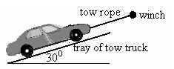
Using a suitable labelled vector diagram to explain your logic, calculate the tension in the rope as it pulled the car up the tray.

(4 marks)

- At a local hockey game, Aimee hits a ball travelling at 14.0 ms⁻¹ north across to Chelsea, who hits it back at 11.0 ms⁻¹ south. If the change in velocity took place in 0.400 s, what was the ball’s acceleration?

(3 marks)

- Aaron throws a small rock horizontally with a velocity of 20.0 ms⁻¹. Given he is standing on the end of a jetty 12m above the water, how far out from Aaron will the rock hit the water?

(4 marks)

- The following shows a beach ball thrown a long distance from one person to another without air resistance.

- If there were air resistance, and the two people didn’t move, would the second still catch the beach ball?

YES NO (Circle) (1 mark)

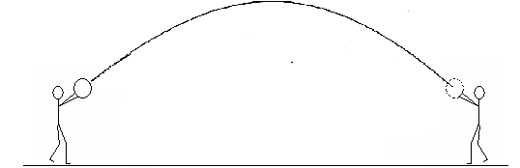
- Draw the expected path of the beach ball with air resistance to justify your answer. (2 marks)
Section B: Problem Solving: 17 marks

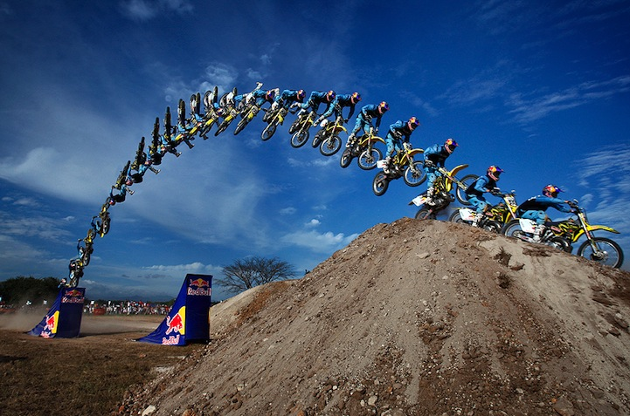
- Charlene is a stunt motor cyclist working on the Red Bull team.

Her major stunt in in a coming show involves her jumping over a 100 m wide gap between a ramp and a hill.

Charlene attempts this by jumping from a 45º ramp at a velocity of 108 kmh⁻¹.

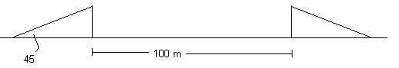

Determine:

  - The horizontal and vertical component of her velocity on leaving the ramp.

(4 marks)

  - Whether Charlene will clear the river at this velocity and angle of projection.

(6 marks)

- A second junior member of the Red Bull team is planning an attempt to jump over a series of cars and trucks and land smoothly on the other ramp as shown below. With what speed in kmH⁻¹ must he ride his bike up the ramp if it is angled at 30˚ to the horizontal?
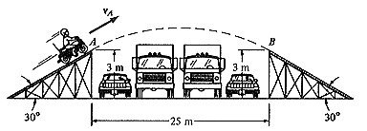

(7 marks)

End of test - More space over if required

